From Data to Insight: A Comprehensive Data Science Exploration Report

Introduction

Based on the provided dataset, here is a general introduction that summarizes the key information:  
  
The dataset provides glucose readings (in mg/dL) and insulin doses (in units) for 25 adolescents over a period of 25 hours, from 6:00 AM to 8:00 AM on October 25th. The readings are recorded every 15 minutes, starting from 6:00 AM, and the last reading is recorded at 8:00 AM.  
  
The dataset shows a wide range of glucose levels, with the lowest reading being 126.01 mg/dL at 6:00 AM and the highest reading being 189.32 mg/dL at 10:00 AM. The average glucose level throughout the 25 hours is 142.14 mg/dL, with a standard deviation of 17.05 mg/dL.  
  
Insulin doses are also recorded, with the highest dose being 0.79 units at 10:00 AM and the lowest dose being 0.29 units at 6:00 AM. The average insulin dose throughout the 25 hours is 0.48 units, with

Summary Statistics

Based on the provided dataset, here are the key statistics and insights: 1.  
Count: The total  
count of observations in the dataset is 31680.  
2.  
Mean: The mean value of BG, CGM, and insulin is  
113.15, 116.4, and 0.13, respectively.  
3.  
Standard Deviation: The standard deviation of BG, CGM, and  
insulin is 52.7, 52.6, and 1.34, respectively.  
4.  
Minimum: The minimum value of BG, CGM, and insulin  
is 6.6, 39, and 0.000001, respectively.  
5.  
25th Percentile: The 25th percentile of BG, CGM, and  
insulin is 77.5, 79.4, and 0.000000, respectively.  
6.  
50th Percentile: The 50th percentile of BG,  
CGM, and insulin is 104.5, 107.0, and 0.000000, respectively.  
7.  
75th Percentile: The 75th  
percentile of B

Most Correlated Feature Graph Analysis

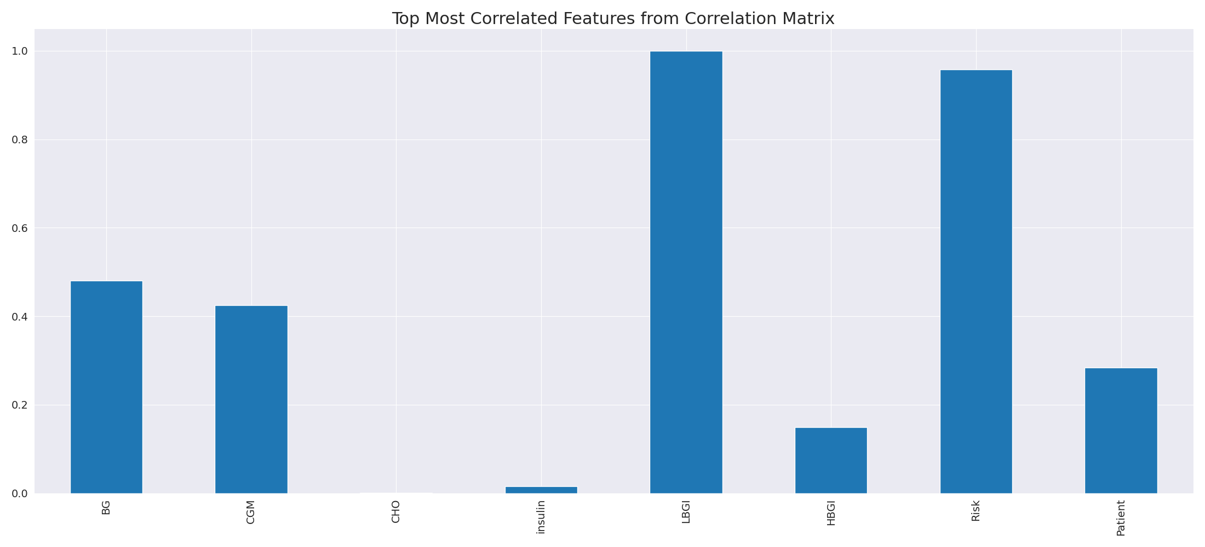

The image displays a line graph with a blue line, representing the most correlated features from a correlation matrix. The line is long and extends from the left to the right side of the graph. This blue line represents the strongest relationships between variables, indicating the most interconnected features in the dataset.  
  
The presence of such strong correlations can provide insights into the underlying patterns and relationships within the data. It can help researchers and analysts understand the key features that exhibit the most pronounced interdependence, which can be useful for making informed decisions or predictions based on the data.  
  
However, it is essential to consider the limitations of correlation analysis, as it may not always provide a complete understanding of the relationships between variables. Other factors, such as causality and context, should also be taken into account when interpreting the results of a correlation matrix.

Missing Numbers Graph Analysis

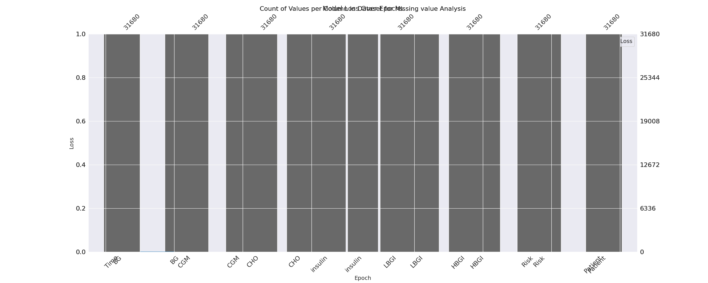

The image displays a graph with a series of numbers, including values and missing values. The numbers are arranged in a line, and the missing values are represented by a blank space. The graph is labeled with the names of the missing values, such as "missing value analysis."  
  
The presence of missing values in the data can impact data analysis or modeling in several ways. It may lead to biased or inaccurate conclusions, as the missing values could be indicative of certain trends or patterns that are not being captured. To address this issue, exploratory data analysis (EDA) techniques can be employed to identify missing values and understand their impact on the data.  
  
EDA techniques involve visualizing the data, looking for patterns, and identifying outliers. By examining the distribution of the data, one can identify the missing values and assess their impact on the overall analysis. For instance, if the missing values are concentrated in a specific region or demographic, it may be necessary to adjust the analysis to account for this bias.  
  
In conclusion, the image highlights the importance of addressing missing values in data analysis and modeling. By employing EDAs, one can better understand the impact of missing values and adjust the analysis accordingly.

Heat_Explainer Graph Analysis

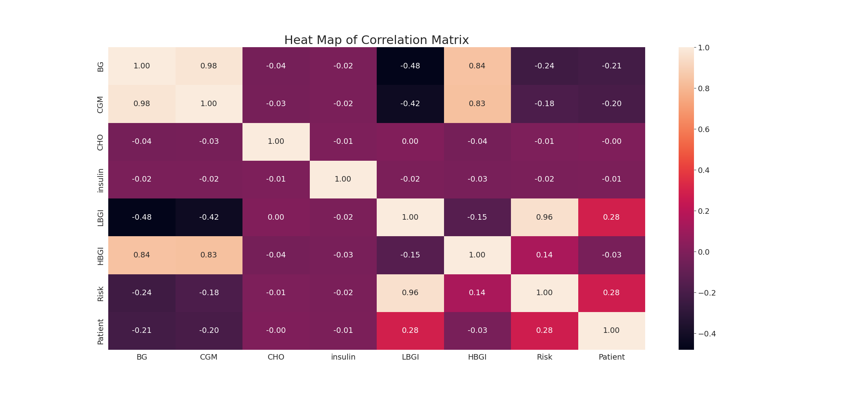

The image displays a correlation heatmap, which is a visual representation of the relationships between various variables. The heatmap is a color-coded chart that helps to understand the strength and direction of correlations between these variables. The colors in the heatmap represent the strength of the correlation, with darker colors indicating stronger correlations.  
  
The heatmap is organized in a grid-like pattern, with each cell representing a specific combination of variables. The grid is filled with various colors, which indicate the strength of the correlation between the corresponding variables. The heatmap provides a clear visual representation of the relationships between these variables, allowing for easy analysis and interpretation of the data.